︱AI -RH201 *SAMTECH*



*Technology*

AI -RH201

3.0MP Full Color Metal Bullet Audio Camera

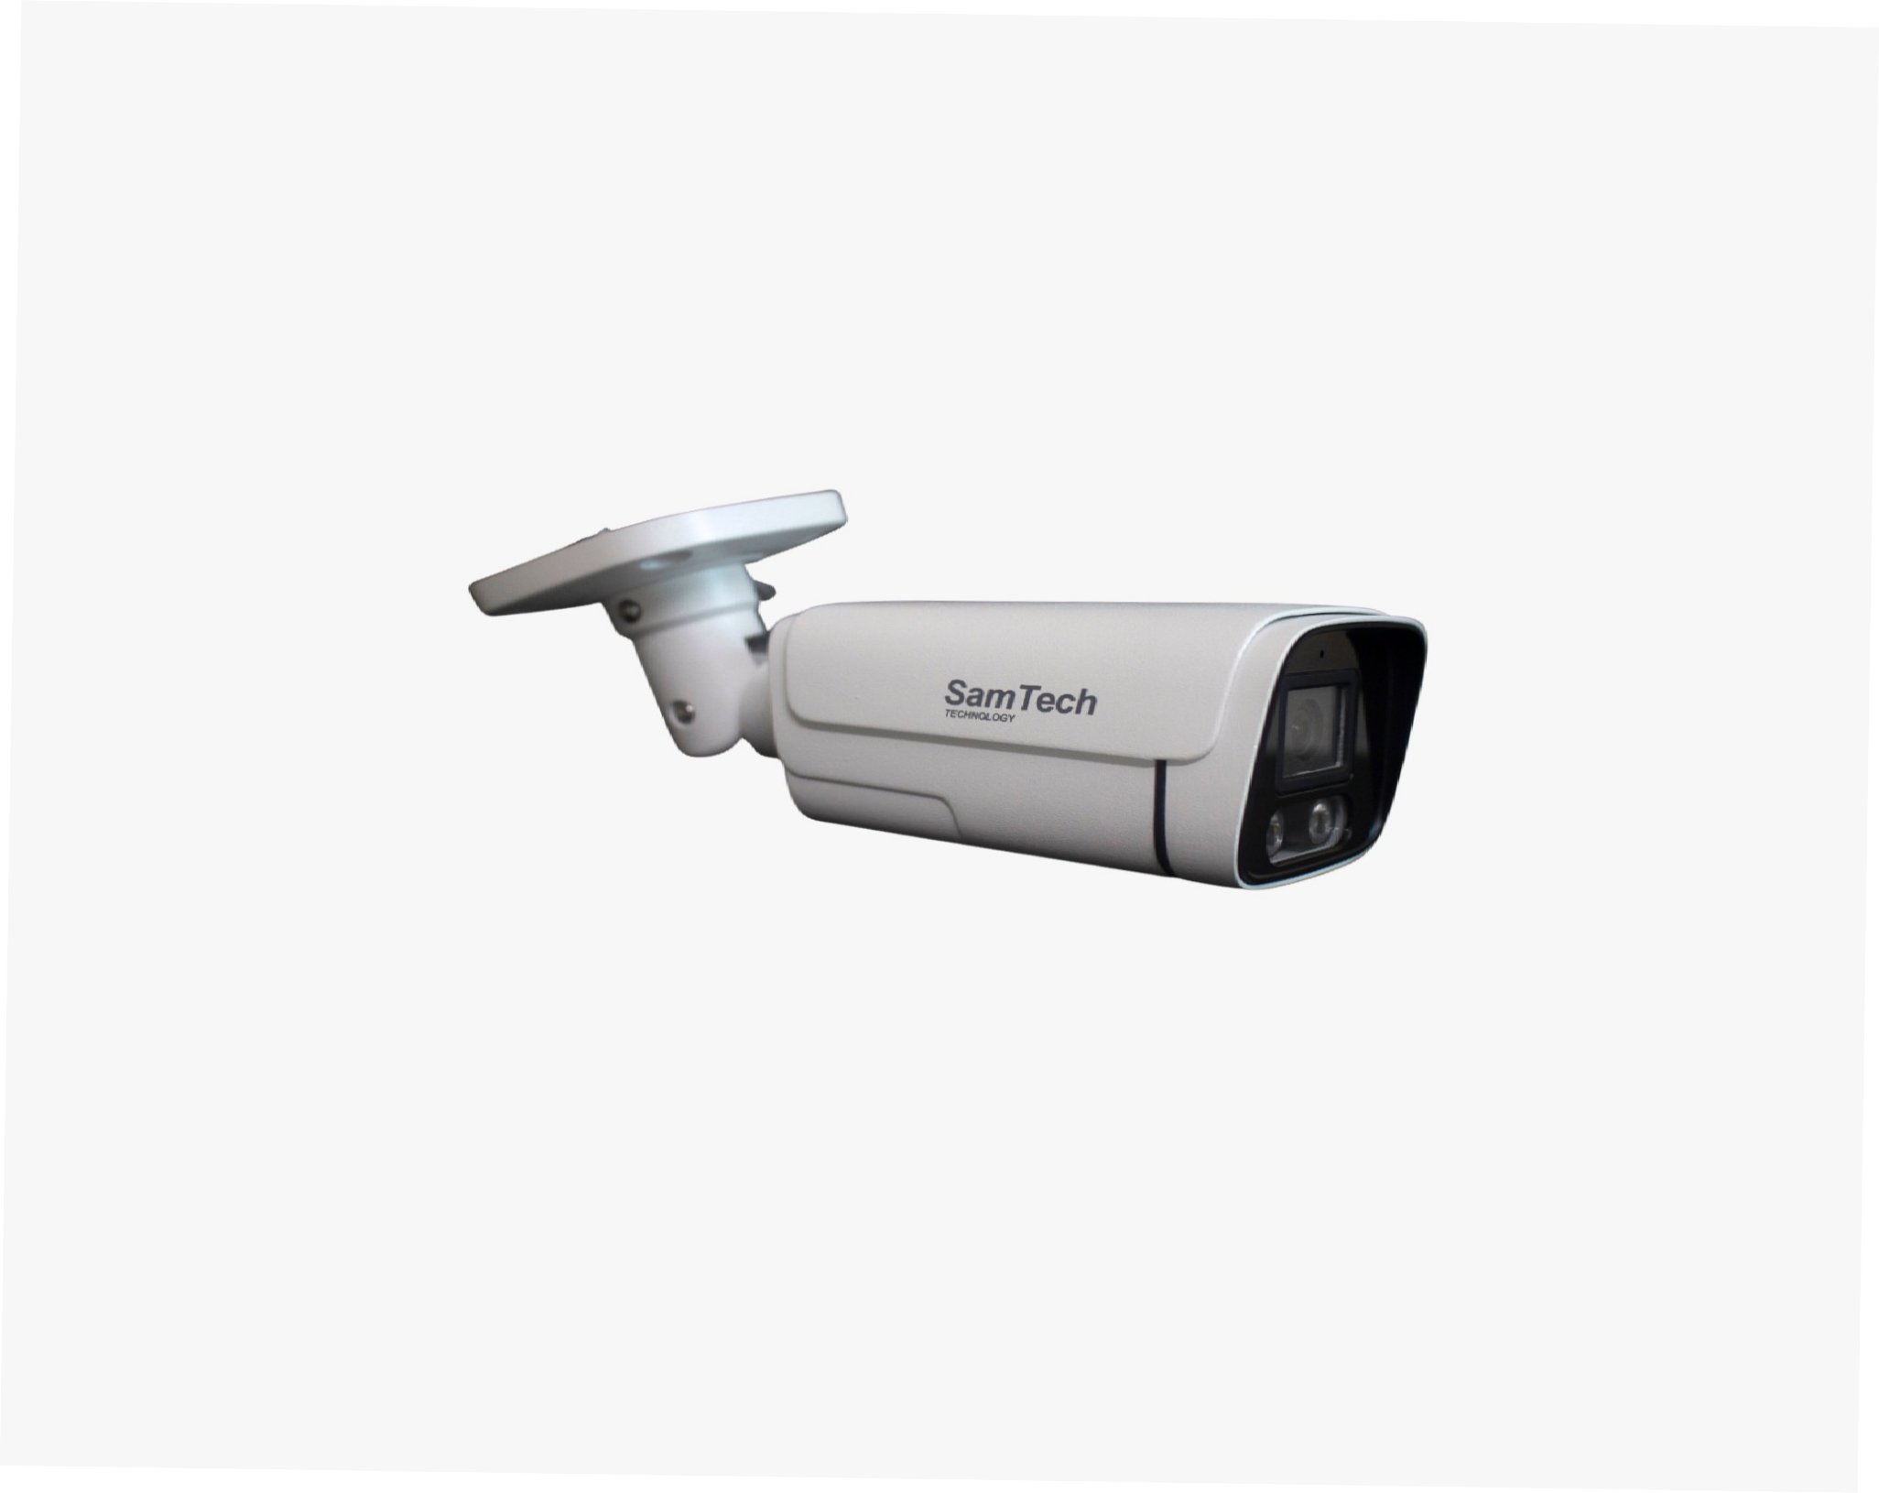

|  |  |
| --- | --- |
| Model Number | AL-RH201 ( Water and Dust Proof ) |
| **Camera 3MP ( Water and Dust Proof )** | |
| Image Sensor | 1/3 HD CMOS Sensor |
| Min. Illumination | Color: 0.01Lux @F1.2( 0Lux IR LED on) |
| Lens | 4/6/8/12/16 mm (Optional) |
| Shutter Time | Auto |
| IR Distance | 30/40/50/80m |
| Effective Pixels | 1280(H)x720(V) and 1960(H)x1080(V) |
| White Balance | Auto |
| Video Output | 1-Channel BNC HDCVI High definition video output/ CVBS standard definition video |
| Video frame rate | 1280x720@25 fps; 1280x720@30 fps, 1280x720@50 fps; 1280x720@60 fps |
| Housing | Metal Bullet |
| Day/Night | Auto(ICR)/Color /B/W |
| Three in One | Video/Audio/Control all in one composite signal |